Abyssinia

i. General

Abyssinia cottage lies up Glenkinglas, on the Strone Estate. It appears on the Second Edition 6 inch OS Map, surveyed in 1897; but not on the First Edition of 1870. It must therefore have been built between the 1870s and the late 1890s.

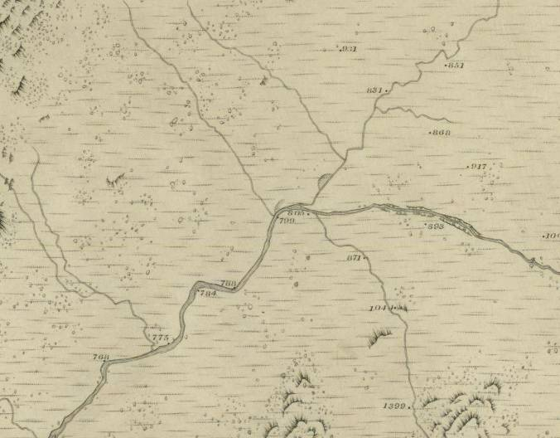 | 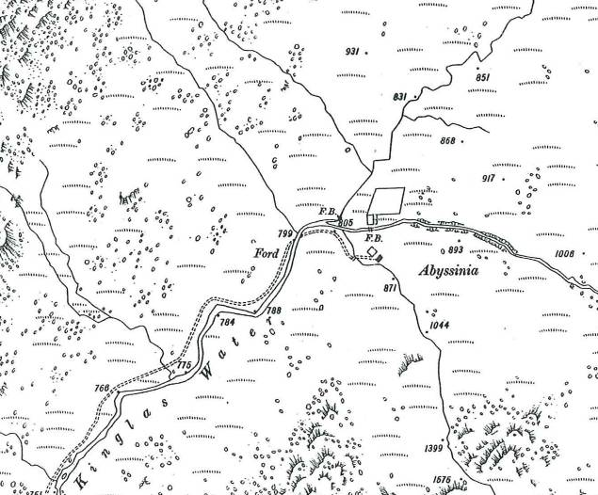
Figure 7: 6 inch Ordnance Survey Map, First Edition 1870. National Map Library of Scotland. | Figure 8: 6 inch Ordnance Survey Map, Second Edition 1897. National Map Library of Scotland.

Abyssinia is a simple structure, rectangular in plan, the principal elevation facing northwest but – for a matter of ease – this is called the north front here. The north facing elevation looks over the Kinglas Water and the bottom of the glen, from a slightly elevated position.

It appears to be a building of two early phases, starting life as a simple three-bay one-and-half storied structure with a central entrance and single window on either side, beneath a double pitched roof. The roof seems likely to have been slated, some of the evidence of a few West Highland type slates are lying in the vicinity, in rubble piles etc. The double-pitched roof is gabled to the east and west.

The structure overall is rubble built with the angles of the openings and the coining of the corners formed of rough hewn larger blocks of stone that are very often shist, but occasionally granite as well. The structure is well and neatly built to a good even exterior face. Sills have generally been robbed, lintels are formed of large single slabs of schist. There is a single, tall narrow window opening in the rear wall to the south. This is slightly offset to the east. There is what appears to be a construction break further west in the south wall. This corresponds to the site of the original gable wall.

The original structure appears to have been extended further to the south by an additional bay. The extension contains a single entrance on the west side. Clearly for some considerable time this structure had been ruinous and has relatively recently undergone considerable rebuilding of the wall heads and reproofing. The new timber structure has a corrugated zinc roof on top, painted red. New windows have been put in to the various window openings and a doorway within the principal entrance. The lower part of the secondary entrance to the south was in filled with cemented rubble work. The new repairs are all in cemented rubble construction, generally using medium stones that are brown with iron oxide, clearly readable and the pointing is of curious detail, struck as opposed to the original detail which was flushed.

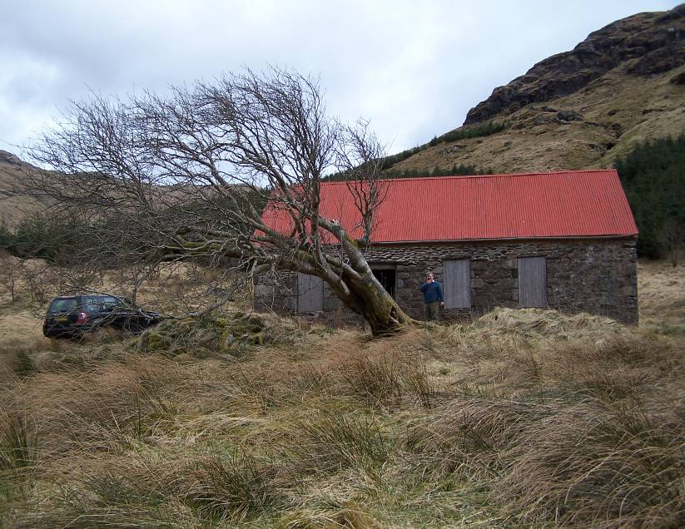 | 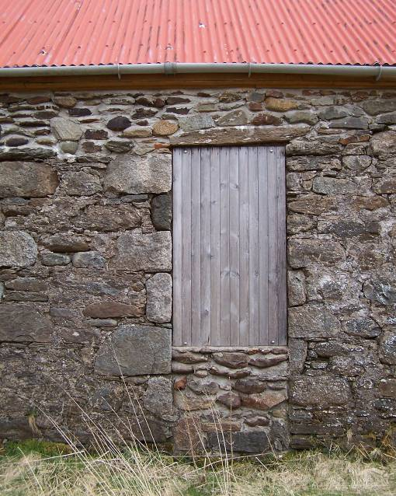
Plate 62: N Elevation with Rowan tree in front. | Plate 63: Construction break with original cottage corner to E (left) and addition to W (right).

The exterior of the west gable wall has not been substantially repointed and this retains earlier pointing, which appears to be a very hard and possibly cementitious lime mortar, which is relatively well preserved. This is flush pointed and almost sneck harled; generally in a fair state of preservation. Elsewhere the pointing detail is much less well preserved.

Outside to the north is a platform which may be partly modern but must surely, at least in part, be early and just beyond the edge of this to the north is a very substantial Rowan tree, now keeling over but clearly of considerable age.

ii. Interior

Internally, there is a masonry cross wall of which fragments still survive to north and south. To the south, this cross wall rises almost to wall head height. The central part of this cross wall is broken away though it seems likely this may have contained a fireplace. Within the surviving gable wall to the east, there is a centrally positioned fireplace at ground floor level. This is very roughly formed up of fieldstones under a schist lintel. The upper parts of the gable appear to have been very substantially rebuilt and retain no other early features that are obvious.
The two windows in the north frontage are heavily splayed internally, the ingoes running down to floor level. The window in the centre of the rear wall is slightly splayed and the ingoes stop at sill level. Although it appears that the western part of the building might be an addition, internally this has no features other than a large iron hook set into the south wall towards the west corner.

The solitary entrance to the N and the lack of windows in this part of the building suggests that this had likely functioned as a byre or possibly as a storage space. It seems likely that the upper level had had further accommodation and there had been a stair up to this. The typical arrangement here would be a straight flight of stairs opposite the principal entrance after a small vestibule area. Again, as is typical in many of these buildings, the solitary rear window is likely relating to a room at the back of the building beneath the stairs.

A lot of rubble has been cleared out of the interior, but so far this has not revealed any details of flooring etc.; the floor is simply earth covered, as it is at the moment.

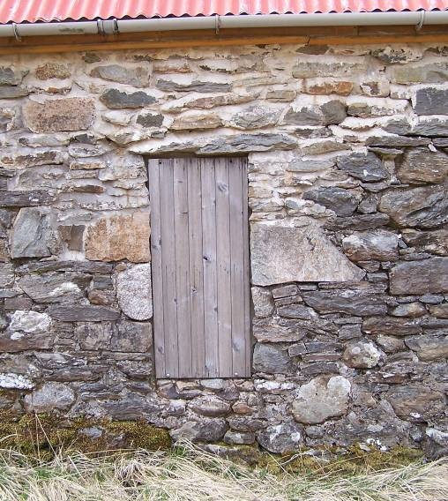 | 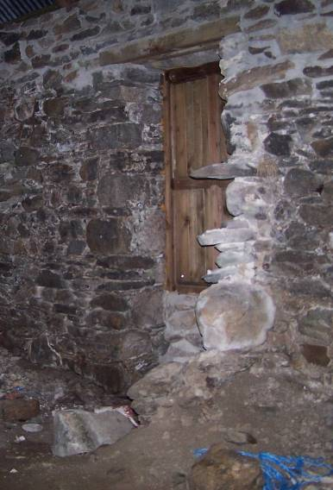 | 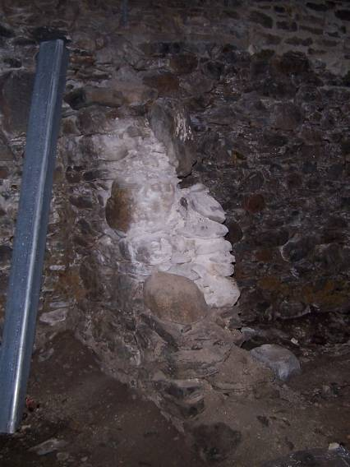
Plate 64: Rear entrance to S. | Plate 65: Internal partition wall / possibly original W gable, view to S. | Plate 66: Internal partition wall / possibly original W gable, view to N.

