Arleigh

i. General

Arleigh is the home of John and Sandra McDonald. The house was built in 2008 by John McDonald himself. It is a simple, rather deep rectangle in plan under a double pitched, slated roof. It is located on the gently rising ground on the south side of Loch Fyne (N.B.: For the sake of this report the way the loch is facing along the side of the house is given as north). The building is 1.5 storeys beneath a substantial double pitched roof. The house is of block-built construction that is harled over in cement externally and painted white. The site is entered off an estate access road by a gravel drive that leads in from the south-east. The gravelled area surrounds the house with a larger area for parking, etc. along the south and east sides. The house is slightly terraced into the rising ground to the south and embanked out to an open, lawned garden area to the north.

ii. External elevations

The principally used entrance is in the south elevation. This consists of broad patio doors reached by a set of three concrete steps. There is a further side entrance in the gabled east elevation. This is reached by a straight flight of five concrete steps. The main entrance that contains the porch is in the north elevation, creating the typical façade with porch towards the estate road and the lochside.

The entrance in the east gable wall is flanked by a small bathroom window on its north side. The entrance on the south elevation lies at the west end. To the east of this there is a broader single window and a small window towards the south-east corner. The garden frontage along the north side of the house has a central entrance which leads on to a raised patio area that extends from the entrance westwards. This is concrete topped and there is a small short flight of three steps leading down at its east end. Both the house and the patio sit on a raised base that is painted black. To the east side of the entrance on the north elevation there is a broad window. On the west side there are French Doors from the living room out on to the raised patio. A principal feature of the north elevation are two substantial and broad dormer windows. Like the roof, these are generally slated with hipped fronts and slated sides as well. All external woodwork trim, the eaves boarding, the boarding framing the windows, etc. are painted a rich teal blue. The window and entrance woodwork is all varnished wood externally that appears to be hardwood. These are all very simply detailed.
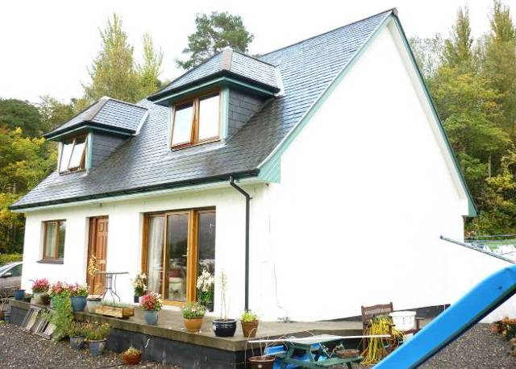
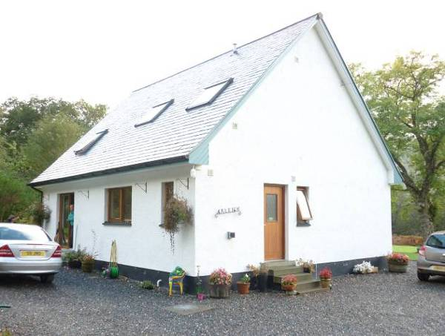

Figure 10 and 11 – External elevations of Arleigh: South and East gable elevation (left), North and West gable elevation (right).

The west gable wall facing the elements has no external openings at all. The patio area from the north side extends around this side and runs into a concrete ramp that runs down to the south. The plot on which the house stands extends extensively down towards the lochside road to the north. A burn runs along the west side of the house running obviously down to the loch, to the north as well. The west side of the house leads to a concrete paved slabbed path that runs round the corner to the principal entrance in the south.

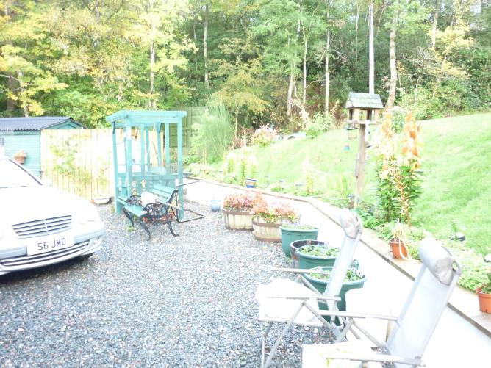
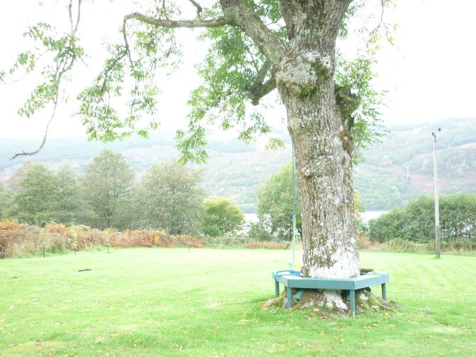

Figure 12 and 13 – Patio area to south-west (left), lawn and bench around tree to north, with Loch Fyne in background (right).

iii. Interior – Ground floor

The house overall is very deep in plan which allows for two rooms depth overall. The principal entrance on the south elevation leads directly into the kitchen/dining room area. This occupies most of the length of the building from the south-west corner along the south side. The room is relatively simply appointed. The woodwork is varnished pine, the doors are unmoulded, apparently of mahogany veneer. Walls rise up to a simple ogee cornice. The fitted kitchen within occupies the south-east corner of the room, the units themselves forming a u-shaped configuration. A pine hardwood worktop sits over units that are painted cream. The kitchen is vinyl floored in a pattern to suggest 9" stone quarries.

At the east end there is a single door to the north-east. This leads to a small vestibule coming in from the external entrance in the east elevation. On the south side of the vestibule a further entrance leads into the utility room (to south). The utility room is fitted with cupboard units running along the east wall. Returning to the north wall of the kitchen area, offset to the east, there are two further doors / entrances. The western one is narrower and leads into a small pantry area that is shelved. The eastern door / entrance leads directly into a stairhall. Along the west side of the hall, there is a straight flight of stairs that rises up from the north to south. This has a well-detailed wooden balustrade rising up from a larger newel post at the base. Balusters and newel post have turned, moulded detailing; all of pine and varnished. The ground floor area apart from the kitchen / dining room is carpeted throughout and the walls are generally lined with plasterboard that is cream painted. In the stairhall this rises up to a cornice of ogee form with a white painted ceiling.

An entrance at the foot of the stair on the west side leads into the drawing room. This principal room occupies the major part of the north-west area of the house. It is simply appointed throughout with cream painted walls rising up to an ogee cornice and ceiling that are painted white. There is a fireplace in the west wall, slightly offset to the south. This has a bolection moulded surround and mantelshelf above, and an electric fire fitted within. Again, this is simply detailed, painted black with a small projecting hearth area below. The principal features of this room are the broad French Doors and patio door in the north side leading straight to the patio terrace to the north.

Returning to the stairhall, at its north end there is a small vestibule that leads to porch area and the external door in the north elevation. The door separating the porch or vestibule from the stairhall is glazed, of hardwood and the fielded glazed panels are of three-over-five configuration. On the north part of the east wall of the stairhall there is a further entrance that leads to a small bedroom. This occupies the north-east corner of the ground floor, with a window in the north wall. The walls are cream painted again rising up to what is here a simple cavetto cornice and the ceiling is painted white.

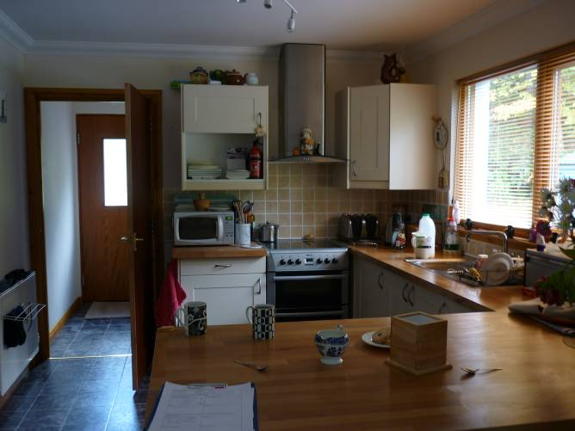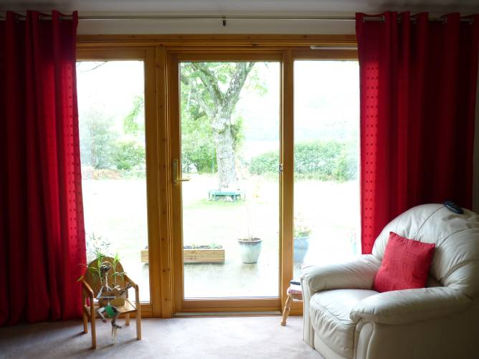
Figure 14 and 15 – Interiors: kitchen area and door leading to vestibule and side entrance to east (left); drawing room with French Doors and views across the lawn to north (right).

An entrance at the south end of the east wall of the stairhall leads to a shower room with a toilet and sink in pale ceramic. The shower occupies the north-east corner and a small window lights the room from the east. The floor is vinyl tiled.

iv. Interior – First floor

The straight flight of stairs leads up to a landing area which occupies the centre south part of the upper level. At the east end of the stair landing area an entrance leads into a bathroom. This has vinyl flooring suggesting a grey sandstone or slate. The bath occupies the east wall, of white ceramic, as is the sink and toilet. A skylight sits in the south pitch.

At the north-east corner of the stair landing is a further entrance into the principal bedroom. This is all simply detailed with coombing to the north and within this sits the broad dormer window overlooking the loch. The walls are cream painted throughout with a white ceiling. Within this room on its west side there is a mirrored sliding door leading to a built-in wardrobe.

The south-east and south-west corners of the stair landing are infilled and occupied by small linen presses that are shelved internally. At the west end of the stair landing there is a further entrance leading into the children's bedroom. This is simply appointed as elsewhere with a Velux window in the south pitch, similar to the bathroom on the south east side. The interior is coombed to the south.

The stair landing angles around to the north-west and gives access into a second principal bedroom occupying the north-west part of the upper level. This is again coombed along the north side and is lit by a broad dormer window on the north side, similar to the principal bedroom on the north-east side.
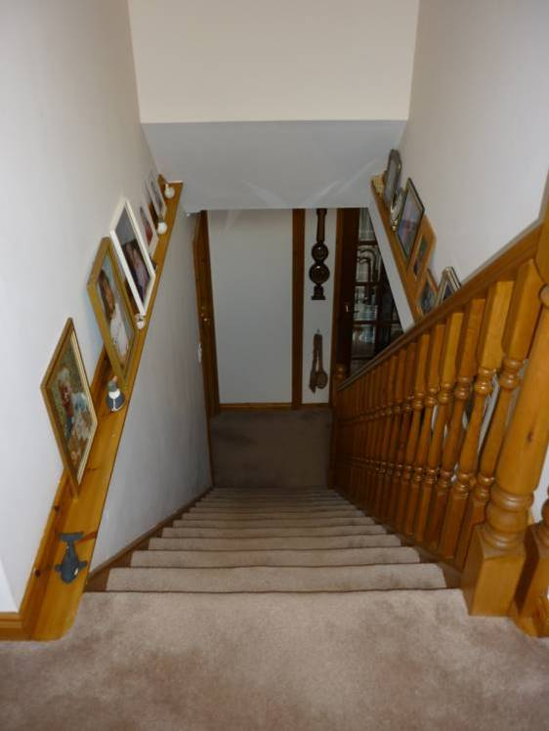

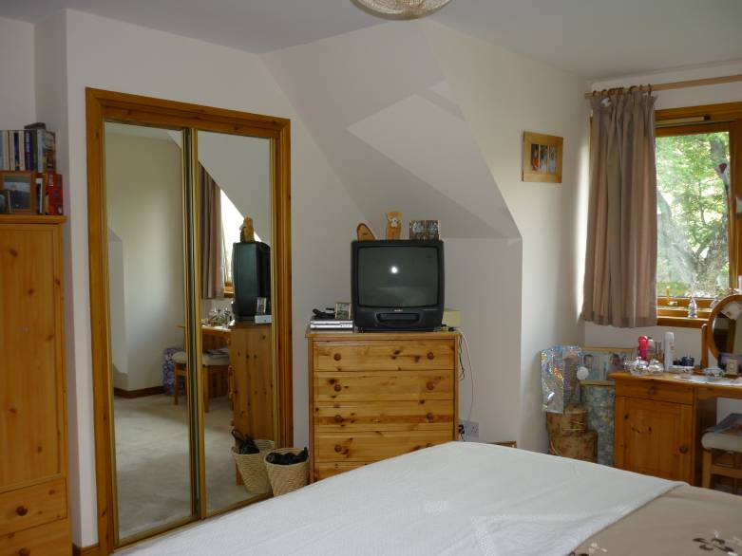

Figure 16 and 17 – Upstairs: stair landing leading down to the stairhall on ground floor level (left); principal bedroom to north-east with mirrored doors to built-in cupboard and dormer window (right).

The upper level is carpeted throughout. All skirtings, architraves, etc. are of pine, detailed with modern moulded profiles. All the doors at this level are of modern plywood with what appears to be a mahogany veneer finish. As for the kitchen / dining area downstairs these are without mouldings or framing. The door furniture throughout is of simply detailed brass.

Overall the house is well proportioned, neatly appointed and well finished.

